**EXPERIMENT:8**

**DATE: 27-09-2022**

**QUESTION:** Design a registration activity and store registration details in local memory of phone using Intents and SharedPreferences

**Xml :**

<?xml version="1.0" encoding="utf-8"?>

<LinearLayout xmlns:android="http://schemas.android.com/apk/res/android"

xmlns:app="http://schemas.android.com/apk/res-auto"

xmlns:tools="http://schemas.android.com/tools"

android:orientation="vertical"

android:layout_width="match_parent"

android:layout_height="match_parent"

tools:context=".MainActivity">

<TextView

android:layout_width="wrap_content"

android:layout_height="wrap_content"

android:text="prgm4 shared preference "

android:id="@+id/textView"

android:layout_alignParentTop="true"

android:layout_centerHorizontal="true"

android:textSize="29dp" />

<EditText

android:layout_width="wrap_content"

android:layout_height="wrap_content"

android:id="@+id/editText"

android:layout_below="@+id/textView2"

android:layout_marginTop="67dp"

android:hint="Name"

android:layout_alignParentLeft="true"

android:layout_alignParentStart="true"

android:layout_alignParentRight="true"

android:layout_alignParentEnd="true" />

<EditText

android:layout_width="wrap_content"

android:layout_height="wrap_content"

android:id="@+id/editText3"

android:layout_below="@+id/editText2"

android:layout_alignParentLeft="true"

android:layout_alignParentStart="true"

android:layout_alignParentRight="true"

android:layout_alignParentEnd="true"

android:hint="Email" />

<EditText

android:layout_width="wrap_content"

android:layout_height="wrap_content"

android:id="@+id/editText2"

android:layout_below="@+id/editText"

android:layout_alignParentLeft="true"

android:layout_alignParentStart="true"

android:layout_alignParentRight="true"

android:layout_alignParentEnd="true"

android:hint="Pass" />

<Button

android:layout_width="wrap_content"

android:layout_height="wrap_content"

android:text="Save"

android:id="@+id/button"

android:layout_below="@+id/editText3"

android:layout_centerHorizontal="true"

android:layout_marginTop="50dp" />

</LinearLayout>

**Java :**

package com.example.program8;

import androidx.appcompat.app.AppCompatActivity;

import android.content.Context;

import android.content.SharedPreferences;

import android.os.Bundle;

import android.view.View;

import android.widget.Button;

import android.widget.EditText;

import android.widget.Toast;

public class MainActivity extends AppCompatActivity {

EditText ed1,ed2,ed3;

Button b1;

public static final String MyPREFERENCES = "MyPrefs" ;

public static final String Name = "nameKey";

public static final String Phone = "phoneKey";

public static final String Email = "emailKey";

SharedPreferences sharedpreferences;

@Override

protected void onCreate(Bundle savedInstanceState) {

super.onCreate(savedInstanceState);

setContentView(R.layout.activity_main);

ed1=(EditText)findViewById(R.id.editText);

ed2=(EditText)findViewById(R.id.editText2);

ed3=(EditText)findViewById(R.id.editText3);

b1=(Button)findViewById(R.id.button);

sharedpreferences = getSharedPreferences(MyPREFERENCES, Context.MODE_PRIVATE);

b1.setOnClickListener(new View.OnClickListener() {

@Override

public void onClick(View v) {

String n = ed1.getText().toString();

String ph = ed2.getText().toString();

String e = ed3.getText().toString();

SharedPreferences.Editor editor = sharedpreferences.edit();

editor.putString(Name, n);

editor.putString(Phone, ph);

editor.putString(Email, e);

editor.commit();

Toast.makeText(MainActivity.this,"Thanks",Toast.LENGTH_LONG).show();

}

});

}

}

**Output :**

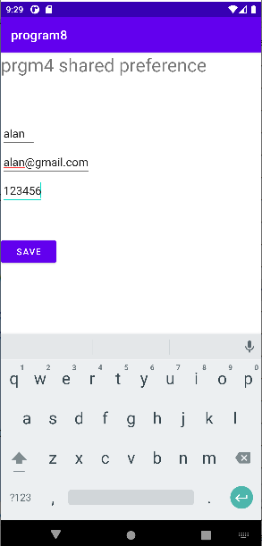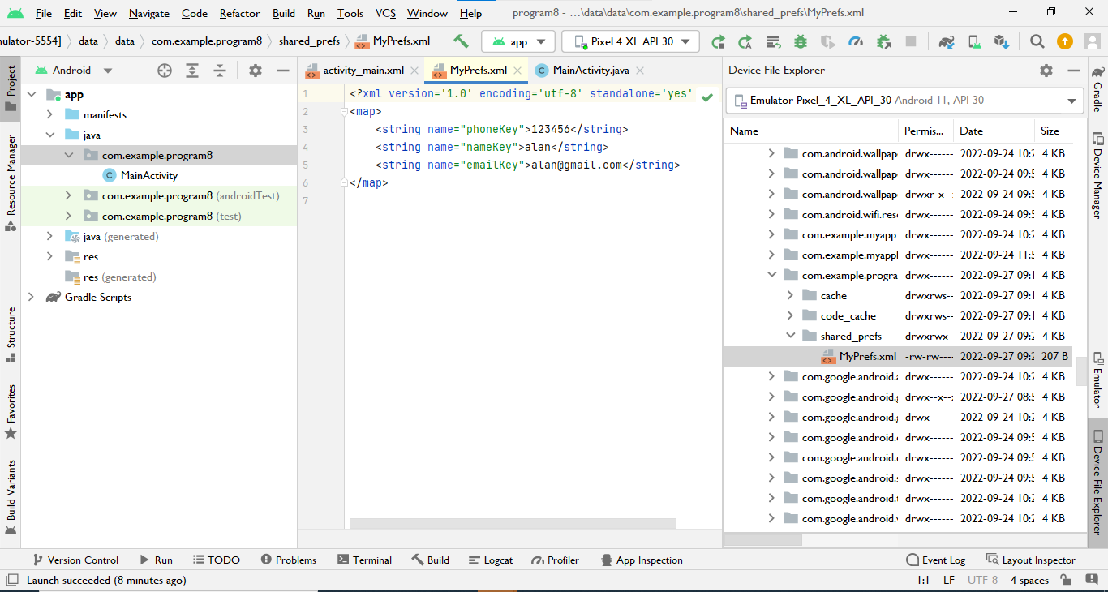

**EXPERIMENT:9**

**DATE: 27-09-2022**

**QUESTION:** Write a program that demonstrates the Activity Lifecycle.

**Xml :**

<?xml version="1.0" encoding="utf-8"?>

<androidx.constraintlayout.widget.ConstraintLayout

xmlns:android="http://schemas.android.com/apk/res/android"

xmlns:tools="http://schemas.android.com/tools"

xmlns:app="http://schemas.android.com/apk/res-auto"

android:layout_width="match_parent"

android:layout_height="match_parent"

tools:context=".MainActivity">

<TextView

android:layout_width="wrap_content"

android:layout_height="wrap_content"

android:text="hi friends"

android:textColor="@color/teal_200"

android:textSize="30dp"

app:layout_constraintBottom_toBottomOf="parent"

app:layout_constraintStart_toStartOf="parent"

app:layout_constraintEnd_toEndOf="parent"

app:layout_constraintTop_toTopOf="parent" />

</androidx.constraintlayout.widget.ConstraintLayout>

**Java :**

package com.example.program9;

import androidx.appcompat.app.AppCompatActivity;

import android.os.Bundle;

import android.util.Log;

public class MainActivity extends AppCompatActivity {

@Override

protected void onCreate(Bundle savedInstanceState) {

super.onCreate(savedInstanceState);

setContentView(R.layout.activity_main);

Log.d("Lifecycle", "onCreate invoked");

}

@Override

protected void onStart() {

super.onStart();

Log.d("Lifecycle", "onStart invoked");

}

@Override

protected void onResume() {

super.onResume();

Log.d("Lifecycle", "onResume invoked");

}

@Override

protected void onPause() {

super.onPause();

Log.d("Lifecycle", "onPause invoked");

}

@Override

protected void onStop() {

super.onStop();

Log.d("Lifecycle", "onStop invoked");

}

@Override

protected void onDestroy() {

super.onDestroy();

Log.d("Lifecycle", "onDestroy invoked");

}

}

**Output :**

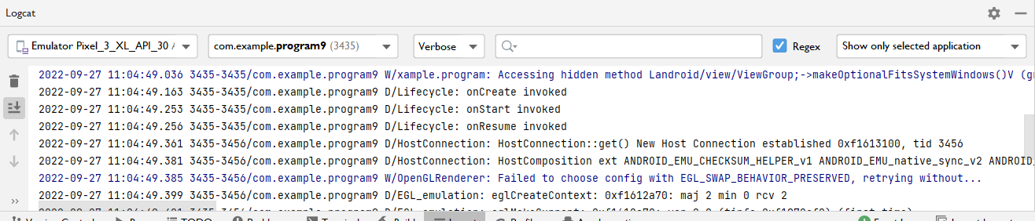

**EXPERIMENT:10**

**DATE: 27-09-2022**

**QUESTION : Listview**

**Xml:**

*<?*xml version="1.0" encoding="utf-8"*?>*<FrameLayout xmlns:android="http://schemas.android.com/apk/res/android"  
 xmlns:app="http://schemas.android.com/apk/res-auto"  
 xmlns:tools="http://schemas.android.com/tools"  
 android:layout_width="match_parent"  
 android:layout_height="match_parent"  
 tools:context=".MainActivity">  
  
 <ListView  
 android:layout_width="wrap_content"  
 android:layout_height="wrap_content"  
 android:id="@+id/studlist"  
 />  
  
</FrameLayout>

**Xml2:**

*<?*xml version="1.0" encoding="utf-8"*?>*<LinearLayout xmlns:android="http://schemas.android.com/apk/res/android"  
 xmlns:app="http://schemas.android.com/apk/res-auto"  
 xmlns:tools="http://schemas.android.com/tools"  
 android:orientation="horizontal"  
 android:layout_width="match_parent"  
 android:layout_height="match_parent">  
  
 <ImageView  
 android:id="@+id/list_icon"  
 android:layout_width="65dp"  
 android:layout_height="65dp"  
 android:layout_margin="5dp" />  
  
 <TextView  
 android:id="@+id/list_title"  
 android:layout_width="match_parent"  
 android:layout_height="65dp"  
 android:layout_margin="5dp" />  
</LinearLayout>

**Java:**

package com.example.program10;  
  
import androidx.appcompat.app.AppCompatActivity;  
import android.os.Bundle;  
import android.widget.ListView;  
import android.widget.SimpleAdapter;  
import java.util.ArrayList;  
import java.util.HashMap;  
  
public class MainActivity extends AppCompatActivity {  
 ListView studlist;  
 String[] studnames = {"alan","binu","albin","amil","devis","febin"};  
 int[] studicons = {R.drawable.*img1*,R.drawable.*img2*,R.drawable.*img3*,R.drawable.*img4*,R.drawable.*img5*,R.drawable.*img6*};  
 @Override  
 protected void onCreate(Bundle savedInstanceState) {  
 super.onCreate(savedInstanceState);  
 setContentView(R.layout.*activity_main*);  
 studlist = findViewById(R.id.*studlist*);  
  
 ArrayList<HashMap<String, Object>> arrayList= new ArrayList<>();  
 for (int i=0; i < studnames.length; i++){  
 HashMap<String,Object> map = new HashMap<>();  
 map.put("studnames",studnames[i]);  
 map.put("studicons",studicons[i]);  
 arrayList.add(map);  
 }  
 String[] from ={"studnames","studicons"};  
 int to[] ={R.id.*list_title*,R.id.*list_icon*};  
  
 SimpleAdapter adapter= new SimpleAdapter(this,arrayList, R.layout.*listitem*,from, to);  
 studlist.setAdapter(adapter);  
 }  
}

output;

